

Quiz #1 IRIS MODEL
Artificial Intelligence
SUBMITTED BY:
UBAID AHMAD
ROLL NO:
2410-0011
SUBMITTED TO:
Sir Hamid Ashfaq
DATE:
26/04/2026

Problem Description:
The Iris Flower Classification is a classic beginner problem in Machine Learning. The goal is to build a model that can automatically identify the species of an Iris flower (Setosa, Versicolor, or Virginica) by looking at four simple measurements: Sepal Length, Sepal Width, Petal Length, and Petal Width. We use the famous Iris dataset, which contains 150 flowers with their measurements and correct species labels.
In this project, we train three different classification models — Gaussian Naive Bayes, Support Vector Classifier (SVC), and Logistic Regression — to learn the patterns from the training data. These models learn how the measurements relate to each species. Once trained, the model can predict the correct species for new, unseen flowers based only on their measurements. This type of model is widely used in real life for tasks like plant identification, medical diagnosis, and any situation where we need to classify things into categories based on numerical features.

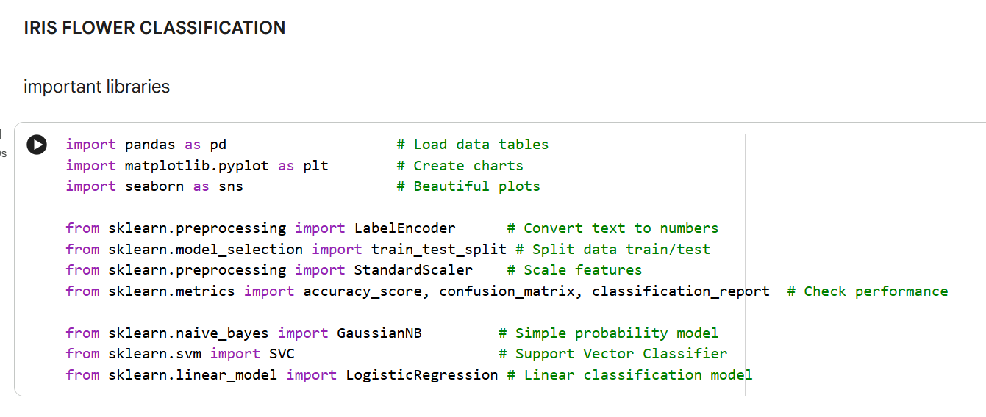
Loading data using pandas :
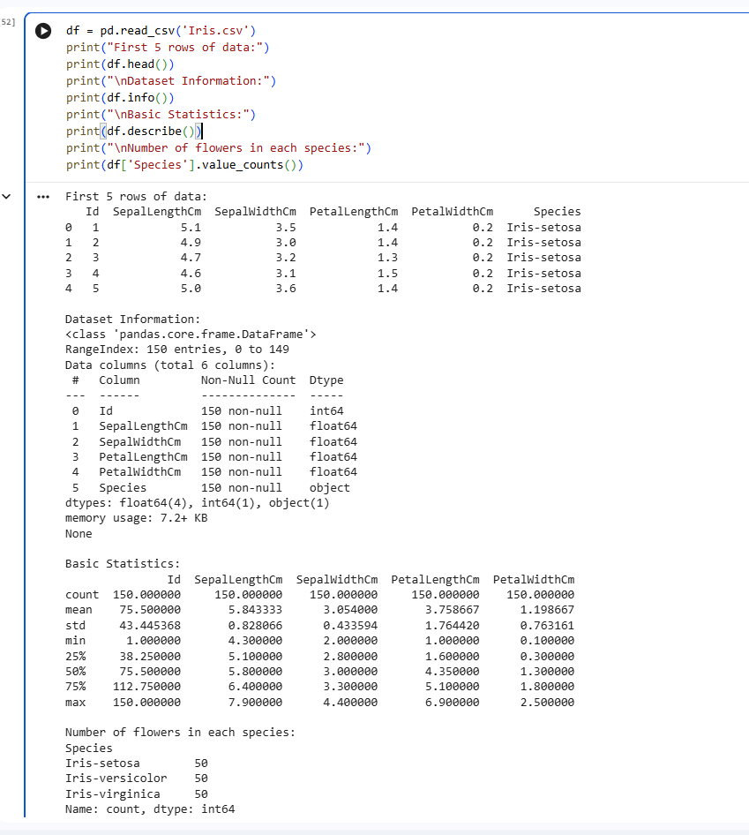
Data visualization using matplotlib and seaborn:
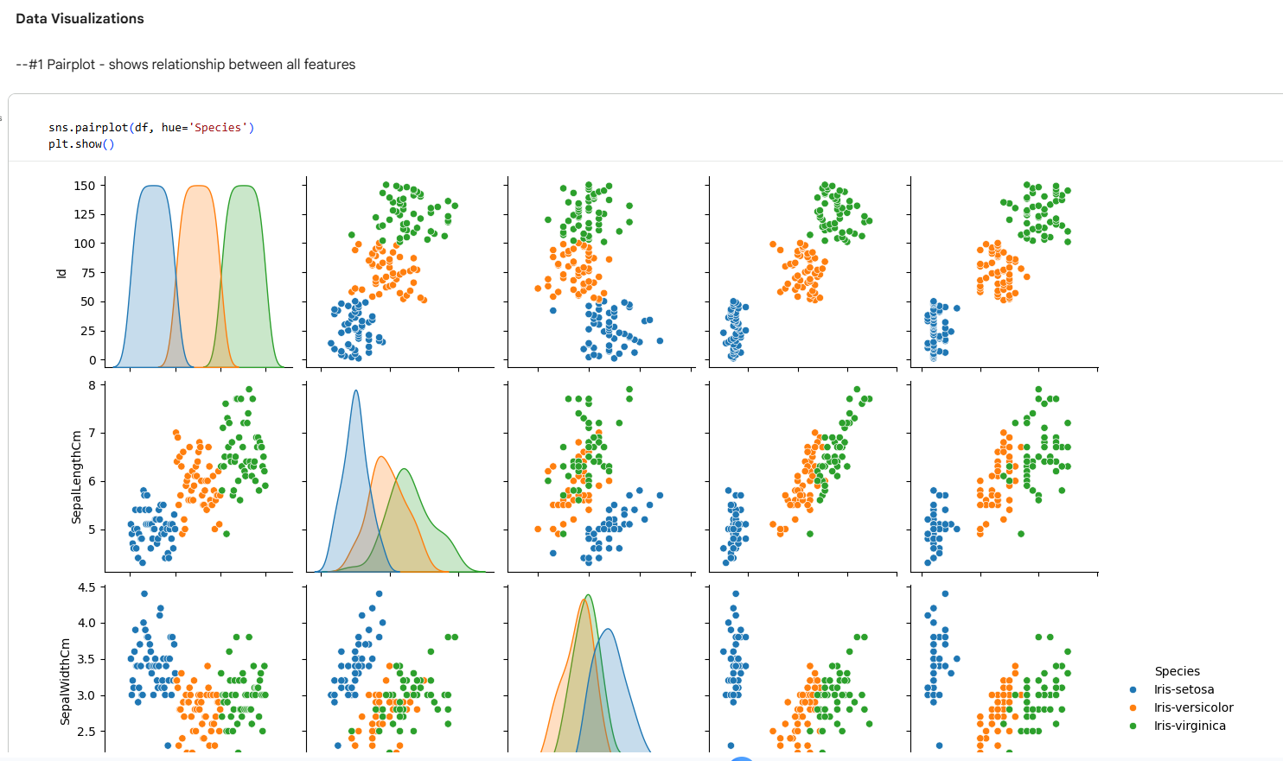
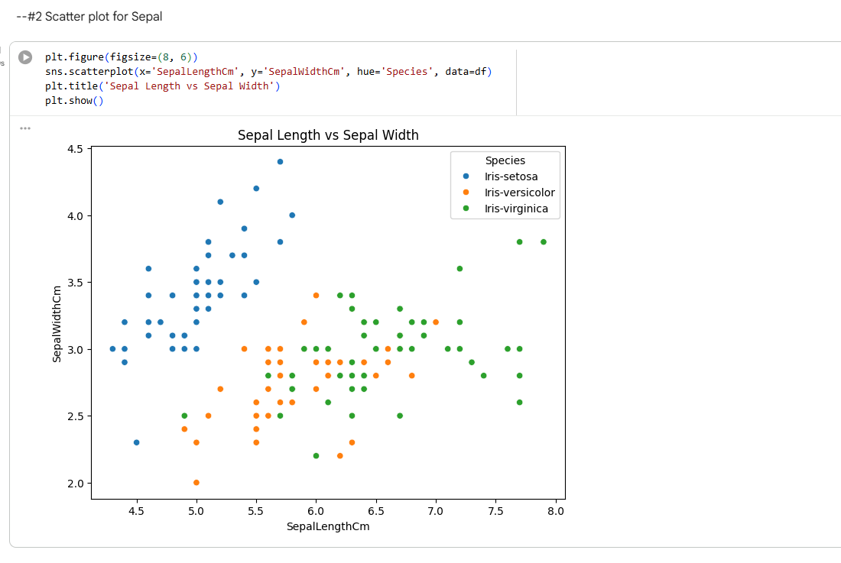
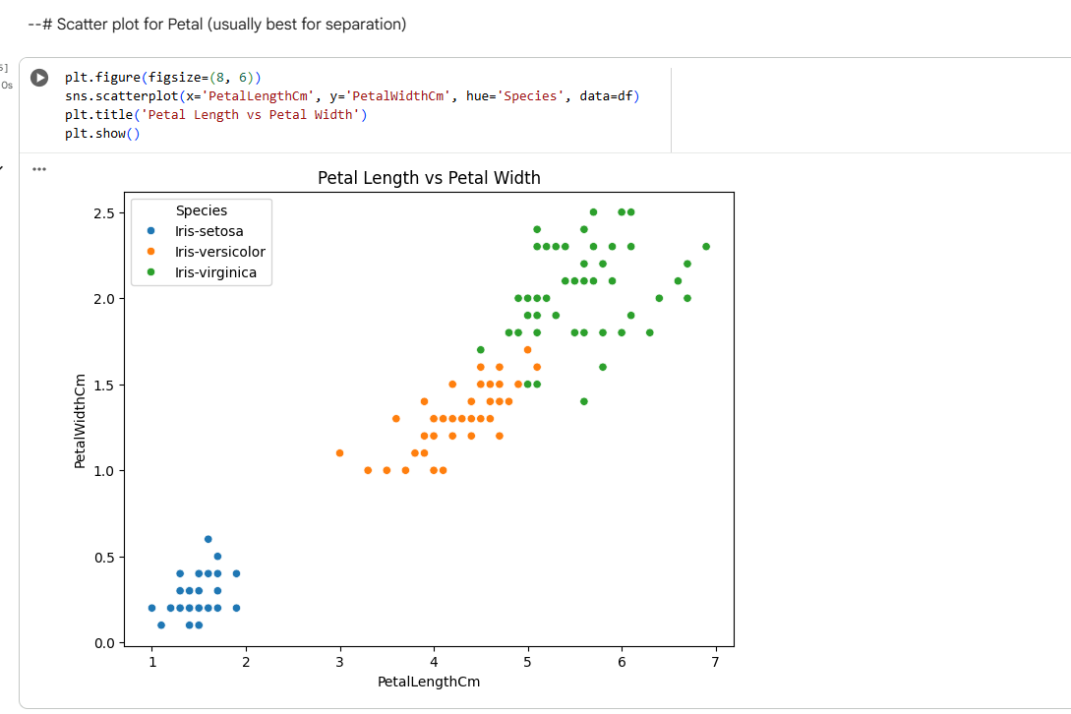
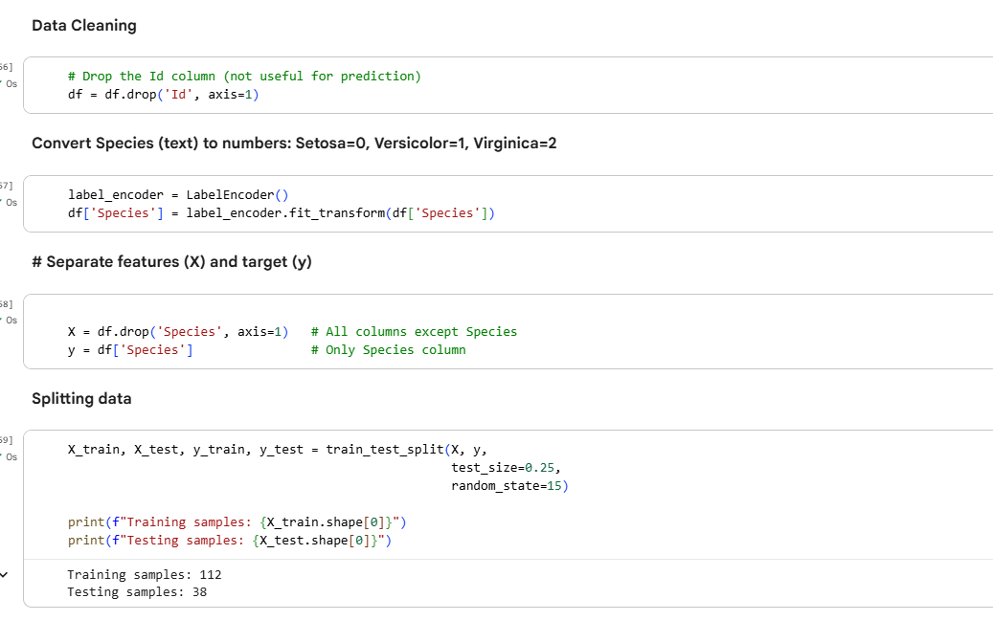
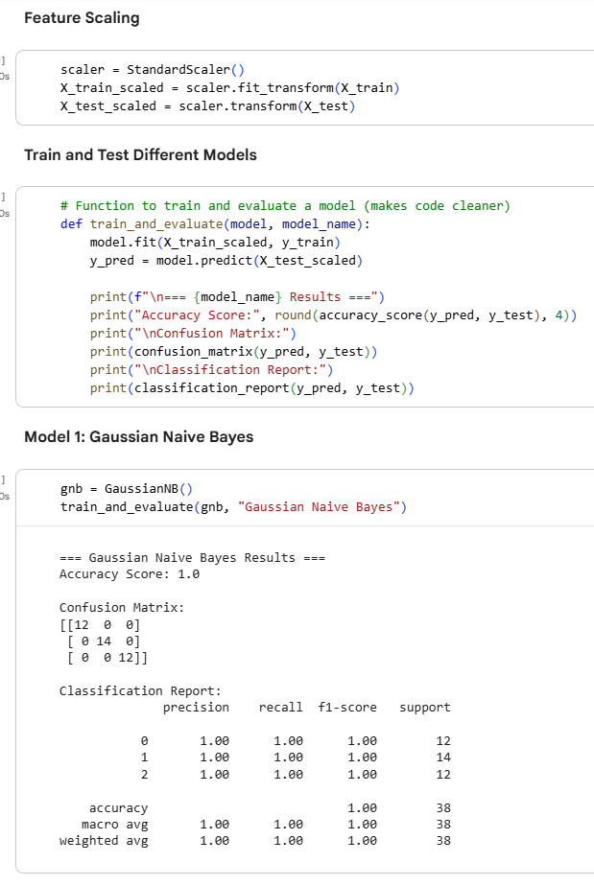
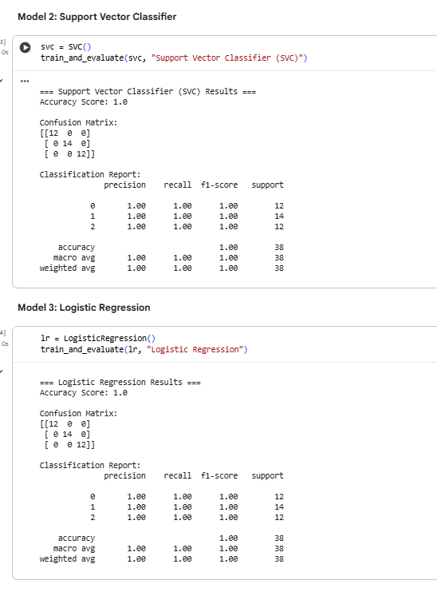


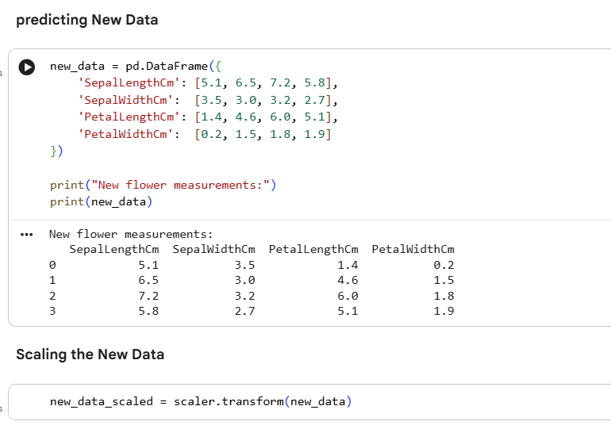
Using SVC Model for Prediction:
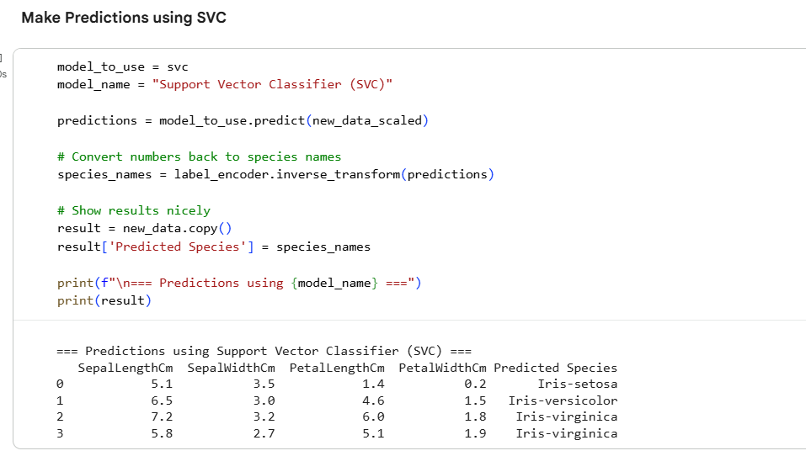

END,,,

